77



Attendance Policy


Approved by: | Board of Trustees |  | Date: 5th February 2026
Last reviewed on: | 22nd January 2026
Next review due by: | 21st January 2027

Contents
Introduction 3
Universal Approach: Establishing a baseline universal attendance approach that benefits all children 3
Recognition - based Approach 6
The Importance of School Attendance at Orchard Community Trust schools 7
Supporting Attendance at Orchard Community Trust Schools 7
Attendance and Punctuality Expectations at Orchard Community Trust Schools 7
Roles and responsibilities of staff at Abbey Hulton Primary School 8
Strategies for using data to target attendance improvement efforts at Orchard Community Trust Schools 9
Absence Definitions ............................................................................................................................................ 11
Authorised Absence 11
Unauthorised Absence 11
Strategy for Reducing Persistent and Severe Absence 11
Notice to improve Letter 12
Penalty notices 12
Policies and Practice 15
Safeguarding Children and Attendance at Abbey Hulton Primary School 16
Review 16

Appendix 1 ......................................................................................................................................................... 17

Introduction
Orchard Community Trust schools are proudly recognised as Inclusive Attendance schools. Our unwavering commitment to attendance centres around child-centric actions, evidence-informed practices, and a shared understanding of everyone's roles and collective responsibilities to promote exceptional attendance.

Orchard Community Trust have adopted the Inclusive Attendance tiered approach.

Universal Approach: Establishing a baseline universal attendance approach that benefits all children

Senior Attendance Champion – Mr Christopher Crook

A Multi-Tiered System of Support
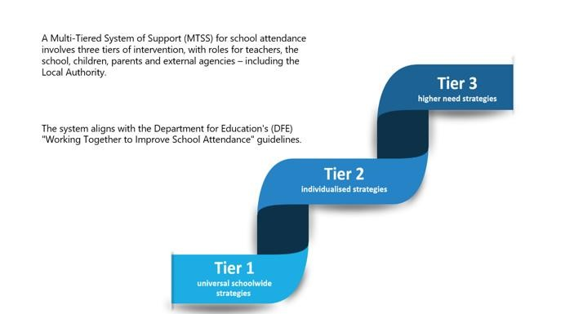

Tier 1
We are committed to providing an education of the highest quality for all our pupils and endeavour to provide an environment where all pupils feel the school is a place they want to be.

We create a calm, orderly, safe and supportive environment where all pupils are keen and ready to learn.
Parents/Carers and pupils play a part in making our school successful. Every child has a right to access the education to which he/she is entitled. Parents and Staff of Orchard Community Trust Schools share the responsibility for supporting and promoting excellent school attendance and punctuality for all.

Every opportunity will be used to convey to pupils and their parents or carers the importance of regular and punctual attendance.

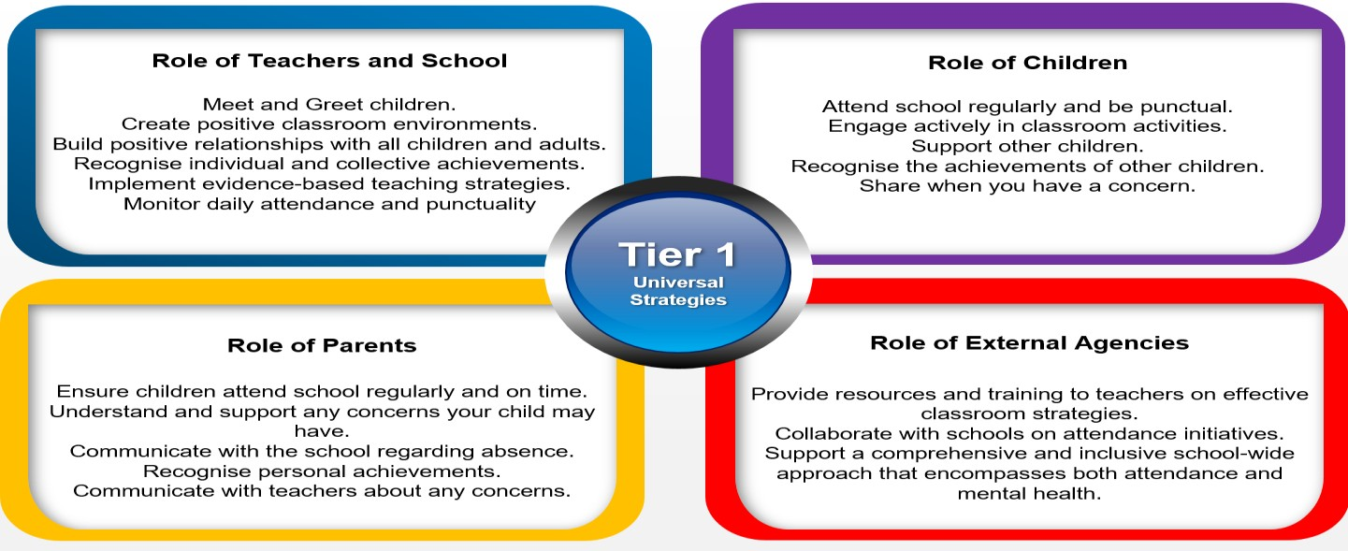
Internal individualised Strategies and Early Help Support: Tailoring strategies to individual needs and providing early help support for persistent attendance challenges.
Tier 2
In the first instance, where attendance has identified as a cause of concern, initial communication will be made with parents/carers to discuss absences to identify and address any barriers that may be causing absences or lates. This will be reviewed as part of the Tier 2 process.
If the absence continues to fall, a letter of concern will be sent and a meeting with the Attendance Team will be arranged, during this meeting we will discuss the previous support offered, make reasonable adjustments, if identified, to the individual strategy plan.

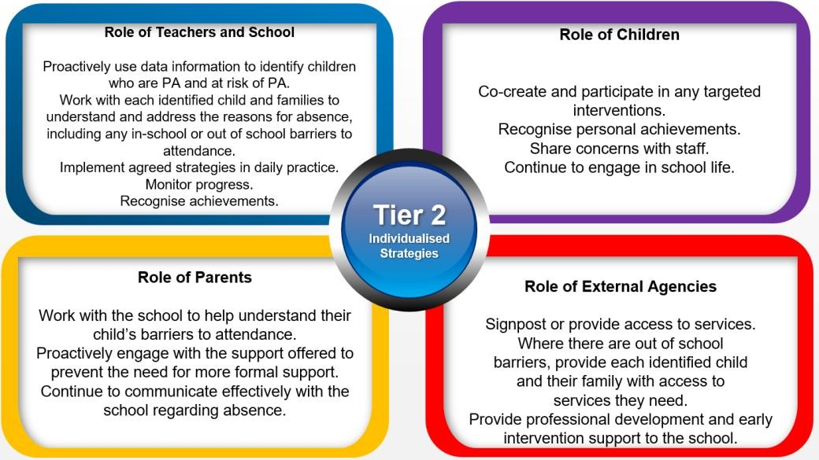

Tier 3
(Statutory Action) Higher Needs Strategies Support: Furnishing specialised support for children, young people, and families with complex attendance requirements, including access to external agency support when necessary.
If the issues have not been resolved and attendance continues to fall a meeting with the Education Welfare officer will be arranged and a Notice to Improve Letter will be issued, this is a formal period of monitoring in conjunction with the Education Welfare Service, this can lead to a referral to Education Welfare for statutory action if unauthorised absences continue.
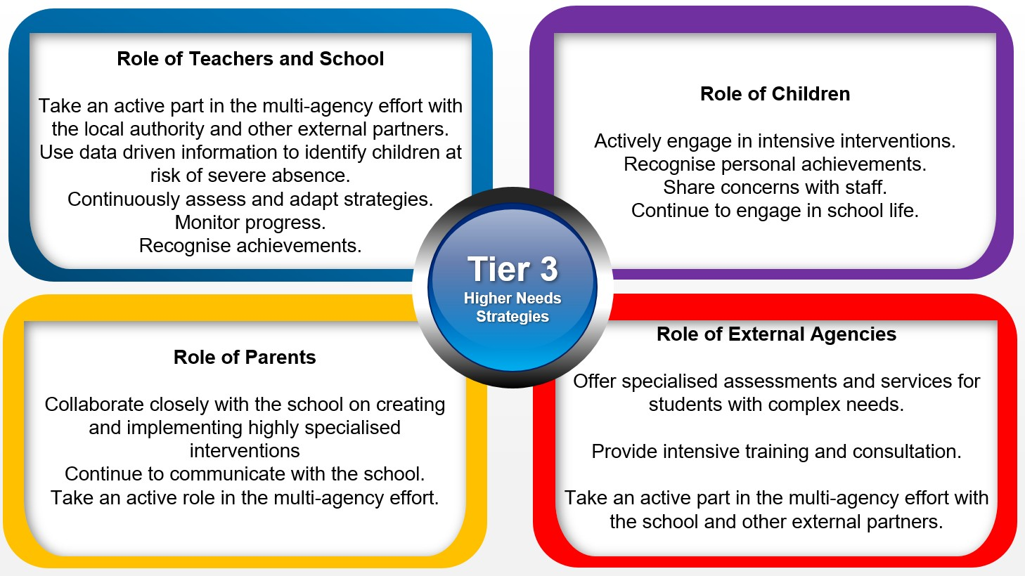

Recognition - based Approach

Our attendance philosophy is rooted in a recognition-based approach that recognises both personal and collective achievements. This approach serves to thwart isolation, prevent victimisation, cultivate positive environments, nurture relationships, foster inclusivity, and ultimately cultivate intrinsic motivation among our children, families, and staff.

Children who have improved attendance, are given a shout out in Monday’s celebration assembly

The Importance of School Attendance at Orchard Community Trust schools
School attendance is not merely a requirement but a fundamental pillar of education. It plays a pivotal role in shaping academic success, personal growth, and future prospects, making it an indispensable aspect of any educational system. Regular attendance to school can have a significant impact on:
- Social Development: School provides a vital social environment for children to interact with peers, develop friendships, and learn essential social skills. Consistent attendance ensures children remain connected to their peer group
- Teacher Interaction: Regular attendance allows for meaningful teacher-child interactions. Teachers can provide personalised support, address questions, and assess individual progress more effectively when children attend regularly
- Academic Achievement: Regular attendance directly correlates with academic success. Children who attend school consistently are more likely to keep up with the curriculum, have higher attainment, and improve their life outcomes
- Preventing Knowledge Gaps: Frequent absences can lead to significant knowledge gaps, making it challenging for children to catch up with missed lessons, potentially resulting in long-term academic struggles
- Knowledge Acquisition: School is where children acquire knowledge and skills that are crucial for their personal and professional growth. Missing days means missing out on valuable and exciting learning opportunities
- Building Routine: School attendance establishes a structured routine in children’s lives, teaching them time management and responsibility, which are valuable life skills
- School Engagement: Children who attend school regularly are more likely to engage in extracurricular activities, sports, and other enriching experiences that contribute to their overall development
- Legal and Parental Responsibility: Parents or guardians are legally responsible for ensuring their child's regular school attendance. Failing to do so can lead to legal consequences
- Community Well-being: High levels of school attendance contribute to the overall well-being of communities.

Supporting Attendance at Orchard Community Trust Schools
To address any identified attendance issues effectively, Orchard Community Trust Schools will implement a range of strategies such as early intervention, support for vulnerable families, intervention programmes, and creating a positive and inclusive school environment. Understanding the specific factors affecting attendance for individual children and families is crucial for developing any targeted interventions and support systems to improve attendance outcomes.

Attendance and Punctuality Expectations at Orchard Community Trust Schools
Regular attendance and punctual arrival are essential for children’s learning, wellbeing, and development.
- Pupils are expected to attend school every day unless there is a valid reason
- As a school we aim for 100% attendance for each child, and we monitor attendance closely
- Absences must be reported to the school on each day via phone before 9am on 01782 235551 option 1, or through class Dojo to Mrs Burton or Mrs Wright or in person at the school office. If parents are able to provide and share medical evidence to support the child’s absence it would assist the school to code correctly and to provide support in a timely manner.
- Authorised absences include:
  - Illness (with parental notification)
  - Medical appointments – it is requested that where at all possible that these appointments are made outside of school hours. If you are able to provide evidence of the appointment this would be appreciated, this can be a text, email or letter, this would also assist the school fully support the pupil. To gain a present mark in the register for each session, the child needs to be in the class at the time the register is taken.
  - If there are any exceptional circumstances, approval by the Headteacher will be needed.
- Unauthorised absences include:
  - Leave of absence in term time unless exceptional circumstances and approved.
  - Absences without explanation
  - Lateness after registration has closed
- Children must arrive on time, ready to start learning.
- The school breakfast club opens at 7:30am for parents who have requested a place for their child (if you require a place, please contact the school office or send a dojo to Mrs Wright in the school office, to see if there any positions available).
- School gates open at 8:30am for all pupils.
- School doors open at 8:30am for all pupils.
- Learning starts at 8:45am for all pupils.
- All pupils are expected to be in school by 8:45am when the gates are closed. After this time your child is classed as late on the register and you will need to sign them in via the main school office.
- Parents/Carers are expected to accompany their child to late gate where they will be asked to sign their child in. This will register your child with a late mark on the register. If your child is persistently late a meeting with parents will be held and support put into place where needed.
- Registers close at 9:15am; if your child arrives after this time they will be marked with a ‘U’ code which is an unauthorised absence. This will have an impact on their attendance and will be discussed with parents/carers through a meeting with the school’s attendance team.
- School finishes at 3:05 for EYFS. School finishes at 3:15 for KS1 and KS2.
- If your child is not collected by 3:20, the late collection policy applies.

Roles and responsibilities of staff at Abbey Hulton Primary School
Name of Staff Member | Roles and Responsibilities | Contact Details
Mr Christopher Crook | Attendance Champion / Head  Teacher | If you wish to contact any staff members that have a responsibility for  attendance, please contact the school office via email or telephone  admin@abbeyhulton.orchardct.org.uk  01782 235551
Mrs Emma Burton | Attendance Manager/Officer
Mr Christopher Crook | Safeguarding Leader (DSL)
Michaela Hill | Education Welfare Officer
Mr Mike Bogg | Governor for School Attendance

Strategies for using data to target attendance improvement efforts at Orchard Community Trust Schools
At Orchard Community Trust Schools we will build a whole school culture around attendance, where we strengthen relationships with families, collaborate across schools and external agencies and support to remove barriers to attendance. We will monitor and track daily attendance, and we will identify patterns of attendance and share data with the local authority for joint action (if required).
The attendance team will analyse data in detail using:
- The whole school cohort and Individual year groups
- Individual pupils
- Demographic groups, e.g., pupils from different ethnic groups or economic backgrounds
- Other groups of pupils, e.g., pupils with SEND, LAC, and pupils eligible for FSM
- Pupils who have an allocated social worker or are known to social care
- A pupil who is absent for prolonged periods, or repeated occasions, which may indicate a safeguarding concern, such as CSE or CCE, particularly county lines
- Pupils at risk of Persistent Absence (PA)
- Pupils at risk of Severe Absence (SA)
- Inform parents half termly of their child’s attendance
- Patterns of attendance, codes used.

Day-to-Day Processes for Managing Attendance at Orchard Community Trust Schools
- Registers are taken electronically, each morning and afternoon session. They are then checked and coded in line with the DfE attendance codes, please refer to the appendix for coding
- Absences will be followed up with parent/carers by telephone/email, dojo messages and texts
- Lates will be recorded on the registers as ‘L’ or ‘U’ (dependent on time stated above)
- We will continue to gain contact with parents/ carers throughout the day if there is no contact, within the morning session
- Children will be signed in and out of school by a member of staff using Inventory, as required

First Day Calling and Safeguarding at Orchard Community Trust Schools As part of daily and weekly monitoring school will:
- Call on the first day of absence, if the absence has not been called in by parents/carers. If there is no contact made via telephone, a text message will be sent to the first contact on the child’s records. If there is no contact made, then an unauthorised absence will be recorded
- On the second day of absence, if there has been no contact with parents or carers, contact will be tried again with all contacts on the child’s records, a text message to contact 1 and the attendance team may complete a home visit to ascertain the reason for the child’s absence. If a home visit is conducted a calling card will be left at the home address, requesting contact be made with the school
- On the third day of absence, there will be a home visit from the attendance team if no contact was made previously. Again, a calling card will be left requesting contact. An email and text will be sent to the registered email address and contact 1
- By day 5 a CME (Child Missing in Education) referral process will be started (Local Authority). This will state the contact attempts made and the results of these contacts, attendance percentages as well as the last date the child/children were in school and any other relevant details
- We will continue to attempt contact via calls, texts, emails and home visits. After the 20th day of absence, the child may be taken off roll, (Child Missing in Education) referral will be submitted to the Local Authority (Child Missing in Education), a new application to either the last school attended, another educational establishment or the Admissions Team at the local Authority will need to be completed by parents/ carers upon their return to the area or UK.
In the context of school attendance and education in the UK, the terms "Persistent Absence," "Risk of Persistent Absence," and "Severe Absence" are used to describe different levels of irregular attendance by students. These terms are important for tracking and addressing attendance issues.
Persistent Absence (PA):
Definition: Persistent Absence is a term used to describe a level of student absence from school that is a significant cause for concern.
Threshold: In England, a student is persistently absent when they have an attendance rate of 90% or below. This means they have missed 10% or more of their school sessions. Risk of Persistent Absence:
Definition: The term "Risk of Persistent Absence" refers to a situation in which a student's attendance is at a level that suggests they are at risk of becoming persistently absent.

Threshold: While there is no specific threshold for "Risk of Persistent Absence," it is typically used to describe students whose attendance is consistently low and becoming a concern, as the school communicates to parents in days, we identify 10 days or more as Risk of PA and we will follow internal school procedures.

How many days off will make your child a persistent absence student?
Half term 1 | 3 ½ days off school from September until October half term holiday, will make your child a PA student
Half term 1-2 | 7 days off school from September until the Christmas holiday will make your child a PA student
Half term 1-3 | 10 days of absence from September until February half term will make your child a PA student
Half term 1-4 | 12 ½ days of absence from September until the Easter holidays will make your child a PA student
Half term 1-5 | 15 ½ days of absence from September until May half term will make your child a PA student
Half term 1-6 | 19 days of absence for the full academic year (September to end of summer term in July) will make your child a PA student
Severe Absence (or Severe Persistent Absence):
Definition: The term "Severe Absence" or "Severe Persistent Absence" is used to describe the most serious cases of non-attendance.

Threshold: Particular focus and support will be provided to pupils who are absent from school more than they are present (those missing 50% or more of school). These severely absent pupils may find it more difficult to be in school or face bigger barriers to their regular attendance and as such are likely to need more intensive support across a range of external agency partners.

Absence Definitions
- Arrival at school after the register has closed
- Not attending school for any reason.

Authorised Absence
- An absence for sickness for which the school has granted leave
- Medical or dental appointments which unavoidably fall during school time for which the school has granted leave
- Religious or cultural observances for which the school has granted leave
- An absence due to a family emergency.

Unauthorised Absence
- Leaving school for no reason during the day
- Preparation and celebration of an event
- Parents keeping children off school unnecessarily or without reason
- Truancy before or during the school day
- Absences which have never been properly explained
- Arrival at school after the register has closed
- Absence due to shopping, looking after other children or birthdays. Absence due to day trips and holidays in term-time which have not been agreed
- Haircuts
- Collection of school uniform.

Strategy for Reducing Persistent and Severe Absence
We will identify children at an early stage who are at risk of becoming persistently absent and severely absent from school.
We will act promptly on data and personalise interventions. These may include:
- Home visits
- Letters/ emails to raise awareness, inform and discuss
- In school meetings
- Half termly updates of each pupil’s attendance to parents/carers
- Pastoral support
- Parental engagement
- Individual plans for children/families to support with any barriers they may have
- Referrals to outside agencies where appropriate
- Have reintegration plans for returning pupils
- Flexible timetables
- Include the voice of the child
- Meeting with the Education Welfare Officer
- Notice to Improve letters.

‘Working together to improve school attendance’ (August 2024) states that:
- Improving attendance is everyone’s business
- Where parents decide to have their child registered at school, they have an additional legal duty to ensure their child attends that school regularly, every day that the school is open.

Notice to improve Letter
A notice to improve letter is a formal period of monitoring, it is the final opportunity for a parent/carer to engage in support and improve attendance before a penalty notice is issued in line with processes set out in the local authority's local code of conduct and issued in conjunction with the local authority.
It will include:
- Details of the pupil’s attendance record showing codes used, unauthorised absences 10/10
- The benefits of regular attendance and parents’ duty under section 7 of the Education Act 1996 • Details of the support provided so far
- Opportunities for further support and the option to access previously provided support that was not engaged with
- A clear warning that a penalty notice may be issued or prosecution considered if attendance improvement is not secured within the improvement period
- A clear timeframe for the improvement period of between 3 and 6 weeks
- Details of what sufficient improvement within that timeframe will look like, no further unauthorised absences.

Penalty notices
Our use of penalty notices follows the statutory guidance on the national framework. (Working together to improve school attendance 2024 p.56 onwards)
Parents whose children fail to attend school regularly are committing an offence (Section 444 Education Act 1996). Penalty notices are issued to parents as an alternative to prosecution where they have failed to ensure that their child of compulsory school age regularly attends school, an agreed alternative learning provision.
A Fixed Penalty Notice may be issued where there is unauthorised absence, unauthorised holidays in term-time and persistent late arrival at school or where parents allow their child to be present in a public place during school hours without reasonable justification during the first 5 days of a suspension or permanent exclusion.
The threshold to consider issuing a penalty notice is 10 sessions (5 days) of unauthorised absence in a rolling period of 10 school weeks. This can be met with any combination of unauthorised absence and does not need to be consecutive. The 10-week period can span different terms or school years.
In individual cases the school and the local authority may move to issue a penalty notice where the threshold has not been met. This might apply, for example where several term time leaves of absence (mini holidays) are taken separated across the year so that they do not meet the threshold or for repeated absence for birthdays or other family events Local authorities may also issue penalty notices related to truancy sweeps.
If the support offered/given is not working or being engaged with and unauthorised absences continue then a Notice to Improve Letter may be issued.
If unauthorised absences continue during the formal monitoring period outlined in Notice to Improve Letter, then an application for a penalty notice will be submitted to the Education Welfare Service. The local Authority may feel that prosecution is more appropriate in certain cases when previous Fixed Penalty notices have been issued.
Only two penalty notices can be issued to the same parent in respect of the same child within a 3-year rolling period, but the second penalty notice will be charged at a higher rate than the first.
The first penalty notice issued to a parent in respect of a particular pupil will be charged at £160 if paid within 28 days. This will be reduced to £80 if paid within 21 days.
A second penalty notice issued to the same parent in respect of the same pupil is charged at a flat rate of £160 if paid within 28 days. Following this, prosecution or other attendance legal interventions may be incurred. There is no right of appeal by parents against a penalty notice. Notices may be issued to each parent liable for the offence. Any payments are to be paid directly to the local authority and if fines are not paid by the end of 28 days, the matter will proceed to court.
The matter would move to an Aggravated Statutory Offence (L4441(a)) if parents/carers have previous convictions for non-school attendance.

Upon receipt of the referral to Education Welfare, the case will be allocated to an Education Welfare Officer for statutory action.

If there is no engagement or improvement then case could proceed to court; this carries a heavier fine, possible custodial sentence and it results in a criminal conviction for the parent/carer.

Exceptional leave Request Form
We believe that children need to be in school for all sessions, so that they can make the most progress possible. Under education law parents may request absence for pupils under exceptional circumstances and proof will be required. Holidays during term time will not be authorised (exceptional circumstances are considered by the Head Teacher only). An Exceptional Leave Request form should be requested by the parent via the school office. *The school takes a hard line on term time leave and fully implements the Local Authorities code of conduct and WTTISA legislation August 2024*. Requests of this nature will only be authorised in the most exceptional circumstances. All such requests for exceptional leave must be handed to the school office four weeks prior to the proposed leave. Any requests for exceptional leave under special circumstances must be made to the Head Teacher only, a meeting will be arranged either in person or by telephone to discuss.
If the pupil is absent due to leave in term-time or suspected leave in term-time, without prior authorisation by the Headteacher, the absence will be recorded on the register with a G or O code which is unauthorised absence. The school will submit a referral to the Education Welfare Service who will issue a Fixed Penalty Notice per parent per child.
If a child is absent from school for more than 20 consecutive school days following the start of the first day of absence, they could be taken off roll, a referral will be submitted to the Children Missing Education team and parents will have to re-apply for a place at the school to which the vacancy may have already been filled. Parent would then need to either contact another educational establishment or the LA Admissions Team for further information.

As a multi-cultural school/authority we allow one day for “Eid Ul Adha” and one day for “Eid El Ftr”: School registers will be marked with the coding “R” (leave of absence for religious observance in respect of other denominations may be granted on application, following advice taken from the relevant advisory authority).
Removal from roll of School/ Children missing in Education (CME)
This policy has been written in accordance with the guidance set out by Stoke-on-Trent City Council Promoting Regular School Attendance – Children Missing Education (CME) which can be found on the school website.

If your child is not seen and contact has not been established with you or any of the named parent/carers by the 5th day of absence, Abbey Hulton Primary School will begin the CME procedure as set down by The Local Authority’s Guidance. We will make all reasonable enquires to establish contact with parents and the child including making enquires to known friends and wider family. On the 10th day a formal referral will be made to the Local Authority CME team. If a child does not attend school for 20 consecutive days, a letter will be sent to parents/carers stating that the child may be off rolled from Abbey Hulton Primary School, (this may be from a leave of absence, move out of area or a move out of the UK).
A return will be made to the local authority when a pupil’s name is deleted from the admission register in accordance with regulation 13(4) to (6) except when a pupil’s name is deleted at or after the end of the last term of the school year when they are in year 6. or Year 11
Help us to help you and your child by making sure we always have an up-to-date contact number. There will be regular checks on telephone numbers throughout the year.
Pupils Moving to a New Address and/or School
Parents/Carers are required to update school if the family/child are moving to a new address, either by contacting the school via email or completing an update information form from the school office. This is to ensure the safeguarding of all children and the school’s admission register is correct.
If you wish to change school throughout the academic year you must complete an in-year transfer form which is available from any school office or online. Pupils are expected to attend the school where they are on roll until placed on roll at the school applied to, once the child is placed at the new school, they will be off rolled at Abbey Hulton Primary School.
The statutory walking distance for children aged up to 8 years is 2 miles and for children aged 8 and over is 3 miles. If the school is allocated beyond these distances parents do retain their parental/carer choice to remain at the school. It would be reasonable to expect parents to travel these distances to get their children to school. If a family moves to a property further away than those distances and the child ceases to attend because of the journey, the ‘reasonable distance’ rule applies. Where children have moved house within these distances, they should continue to attend their school until they start at a nearer school. If parents/carer choose to attend a school out of the statutory distance this is parental/carer choice and statutory distance regulations would not apply.
Elective Home Education
Parents must submit written notification of their intention to home educate and request that their child be removed from the school roll. This notification should be addressed to the Headteacher and must explicitly state the parent’s wish to deregister the pupil. While a reason is not legally mandatory, providing it is encouraged to facilitate a smoother transition.
Upon receiving the parental request, the Headteacher is obligated to deregister the pupil and notify the Local Authority (LA). If the child is attending a special school under a Section 7 Education, Health and Care Plan (EHCP), the parent must also obtain the LA’s consent before removal.
Local Authority Referral and Contact
Upon deregistration, the school will submit a referral to the Local Authority (LA) by forwarding the notification letter and confirming that the registration has been removed. The LA has a statutory duty to contact the family to ensure the provision of suitable and full-time home education in accordance with Section 7 of the Education Act 1996. The LA will offer an informal meeting with the parents (and optionally the pupil) to discuss education provision, share guidance, evaluate its suitability, and offer support where needed.

Policies and Practice
This attendance policy operates within the framework of statutory attendance regulations outlined in the Education (Pupil Registration) (England) Regulations 2006 and subsequent amendments. We adhere to the following key attendance acts in the UK:
Education Act 1996: The Education Act 1996 is the primary piece of legislation that sets out the legal framework for school attendance in England and Wales. It outlines the responsibilities of parents, carers, and schools in ensuring regular school attendance. Sections 444-447 of the Act deal with offenses related to non-attendance and penalties for parents and carers.
Education (Pupil Registration) Regulations 2006: These regulations specify the procedures for registering pupils and maintaining attendance records in schools in England. They also define the circumstances in which a pupil can be marked as absent or present.
Education (Pupil Registration) (England) (Amendment) Regulations 2013: These regulations amended the 2006 regulations and introduced stricter rules on authorizing term-time holidays. Under these regulations, headteachers are only allowed to grant leave of absence in exceptional circumstances.
School Attendance Code of Practice: The School Attendance Code of Practice provides guidance to schools, local authorities, and parents on the law and procedures relating to school attendance and absence. It sets out the principles for promoting good attendance and dealing with poor attendance.
Local Authority School Attendance Guidance: Each local authority in the UK may provide its own guidance and policies on school attendance. Schools should be aware of and follow the specific guidance issued by their local authority.
Department for Education (DFE) Guidance: The DFE periodically issues guidance documents and updates related to school attendance. Schools should stay informed about the latest DFE guidance 2024 and follow any recommendations or requirements outlined in these documents.
Child Employment Legislation: Legislation such as the Children and Young Persons Act 1933 and the Children (Performances) Regulations 1968 govern the employment and attendance of children involved in performances, modelling, and other activities outside of regular school hours.
Children Missing Education (CME) Statutory Guidance: This guidance outlines the responsibilities of local authorities in identifying and tracking children who may be missing education, including those who are not on a school roll or are not receiving suitable education.
Section 19 of the Education Act 1996 (England and Wales) outlines the duty of local authorities in ensuring that suitable education is provided for children of compulsory school age.
Additional Policies aligned to the Attendance Policy at Orchard Trust Community Schools
- Behaviour Policy
- Teaching and Learning Policy
- Safeguarding Policy
- Mental Health Policy
- SEND and inclusion Policy
- Pupil Premium Policy
- Children with Medical Needs Policy

Safeguarding Children and Attendance at Abbey Hulton Primary School
The school has a duty to safeguard the welfare of all students. Any concerns about a child's attendance will be investigated promptly to ensure their well-being.

Unexplained or extended absences will trigger safeguarding procedures, including home visits and communication with relevant agencies.

We follow Keeping Children Safe In Education guidance to ensure safe practices.

Review
This Attendance Policy will be reviewed annually by the school's governing body to ensure its effectiveness and compliance with statutory requirements. Any amendments will be communicated to staff, parents, and carers as necessary.

Appendix 1
Coding Attendance in line with DFE guidance 2024:
Code /\ (Present at the school):

Pupils must be present during registration to be counted
- If a pupil leaves after registration, they are still counted as attending for statistical purposes Code L (Late arrival before the register is closed):
- The pupil arrives after the register starts but before it closes
- Schools should discourage late arrival and set a consistent time limit for open registration, not exceeding 30 minutes
- If a pupil arrives late after the register closes, mark them as absent using code U or another appropriate absence code Code K (Attending education provision arranged by the local authority):
- Pupil attends educational provision arranged by the local authority, not by the school
- Examples include attending courses at college or receiving home tutoring
- Schools must record the nature of the provision and ensure notification of absences
Code V (Attending an educational visit or trip):
- Pupil attends a school-arranged educational visit or trip supervised by school staff
- Must take place during the recorded session
- If pupil doesn't attend, record absence using relevant absence code Code P (Participating in a sporting activity):
- Pupil attends an approved educational sporting activity
- Criteria for recording attendance include approval by the school, educational nature of the activity, and appropriate supervision
- Schools must ensure safeguarding measures and record absences with relevant codes Code W (Attending work experience):
- Pupil attends work experience as part of their education arranged by the local authority or school
- Criteria for recording attendance are similar to other approved educational activities
- Schools must ensure safeguarding measures and record absences with relevant codes Code B (Attending any other approved educational activity):
- Pupil attends an approved educational activity other than sports or work experience
- Criteria for recording attendance are similar to other approved educational activities
- Schools must record the nature of the activity and ensure safeguarding measures Code D (Dual registered at another school):
- Used when a pupil is registered at more than one school, indicating absence with leave to attend the other school
- Main examples include attendance at a pupil referral unit, hospital school, or special school temporarily
- Schools must promptly follow up on unexpected or unexplained absences to avoid double counting
Code C1 (Leave of absence for regulated performance or employment abroad):
- Schools grant leave for pupils to participate in regulated performances or employment abroad under specific circumstances
- Criteria for granting leave include licenses issued by local authorities or exemptions
- Schools must record the absence using this code and consider its impact on the pupil's education Code M (Leave of absence for medical or dental appointment):
- Schools encourage appointments outside of school hours; otherwise, prior agreement is necessary
- Leave of absence is granted under specific conditions, including exceptional circumstances
- Absences for medical or dental appointments are recorded using this code Code J (Leave of absence for interview for employment or admission):
- Schools can grant leave for pupils to attend interviews for employment or admission to another educational institution
- Applications for leave must be made in advance, and leave is granted based on specific criteria
The interview must occur during the recorded session, and the absence is classified as authorized Code S (Leave of absence for studying for a public examination):
- Schools can grant leave for pupils to study for public examinations under specific conditions, agreed in advance with parents
- Study leave should be granted sparingly, and provisions must be made for pupils who choose to continue attending school for revision
- Absences for studying for public examinations are recorded using this code
Code X (Non-compulsory school age pupil not required to attend school):
- Schools can grant leave for non-compulsory school-age pupils to attend school part-time under certain circumstances
- Absences for non-compulsory school-age pupils are recorded using this code, with exceptions noted
- For pupils subject to a part-time timetable, this code should not be used, and appropriate absence codes should be applied
Code C2 (Leave of absence for compulsory school age pupil subject to part-time timetable):
- Schools can grant leave for compulsory school-age pupils to temporarily reduce their timetable to parttime in exceptional circumstances, agreed upon with parents
- Absences for pupils with part-time timetables are recorded using this code, ensuring agreement between the school and parents
Code C (Leave of absence for exceptional circumstances):
- Schools may grant leave of absence at their discretion, but only for exceptional circumstances
- Each application is assessed individually, considering specific facts and circumstances
- Absences for exceptional circumstances are recorded using this code, ensuring compliance with regulations and discretion exercised by the school Code T (Parent traveling for occupational purposes):
- Used when a pupil's parent(s) is traveling for trade or business, and the pupil is traveling with them
- Schools should only request proof of occupational travel when genuine doubt exists about the reason for absence
- Pupils should ideally attend schools where their parents are traveling, being dual registered at both their main school and the one they're temporarily attending
- Classified as authorized absence for statistical purposes Code R (Religious observance):
- Used when a pupil is absent on a day exclusively set apart for religious observance by their religious body
- Schools may seek guidance from the parent's religious body to ascertain such days
- Strategies such as setting term dates around religious observance days are encouraged
- Classified as authorized absence for statistical purposes
Code I (Illness - not medical or dental appointment):
- Indicates a pupil's inability to attend school due to illness, both physical and mental health related
- Schools should not routinely request medical evidence but may do so when necessary
- Classified as authorized absence for statistical purposes Code E (Suspended or permanently excluded and no alternative provision made):
- Used when a pupil is suspended or permanently excluded, and no alternative provision has been arranged
- Alternative provision should be arranged within six consecutive school days of suspension or permanent exclusion
- Classified as authorized absence for statistical purposes
Code Q (Unable to attend school because of a lack of access arrangements):
Indicates a pupil's inability to attend school due to a failure by the local authority to provide access arrangements
- Classified as not a possible attendance for statistical purposes Code Y1 (Unable to attend due to transport normally provided not being available):
- Used when a pupil can't attend because the school is beyond walking distance and the usual transport provided by the school or local authority is unavailable
- Walking distances for different age groups are specified
- Classified as not a possible attendance for statistical purposes Code Y2 (Unable to attend due to widespread disruption to travel):
- Indicates a pupil's inability to attend school due to widespread travel disruptions caused by emergencies at the local, national, or international level
- Classified as not a possible attendance for statistical purposes
Code Y3 (Unable to attend due to part of the school premises being closed):
- Used when part of the school premises is unusable, and the pupil cannot practically be accommodated in the remaining usable parts
- Classified as not a possible attendance for statistical purposes Code Y4 (Unable to attend due to the whole school site being unexpectedly closed):
- Applied when the entire school site is unexpectedly closed, such as due to adverse weather
- Attendance registers are not taken, and pupils are marked with this code to signify the closure
- Not applicable for planned closures like weekends or holidays
- Classified as not a possible attendance for statistical purposes Code Y5 (Unable to attend as pupil is in criminal justice detention):
- Used when a pupil is unable to attend due to being in police detention, remanded, or serving a sentence of detention
- Communication with the Youth Offending Team is encouraged to support educational needs during detention
- Classified as not a possible attendance for statistical purposes Code Y6 (Unable to attend in accordance with public health guidance or law):
- Applied when a pupil's travel or attendance at school would violate public health guidance or legislation related to disease transmission
- Classified as not a possible attendance for statistical purposes Code Y7 (Unable to attend because of any other unavoidable cause):
- Used for an unavoidable cause preventing a pupil from attending school, not covered by other specific codes
- The nature of the unavoidable cause must be recorded
- Classified as not a possible attendance for statistical purposes Code G (Holiday not granted by the school):
- Used when a pupil is absent for a holiday that the school did not approve in advance
- Schools cannot retrospectively grant leave of absence, and absence for holidays without prior approval is considered unauthorized
- Classified as unauthorized absence for statistical purposes Code N (Reason for absence not yet established):
- Employed when the reason for a pupil's absence has not been determined before the register closes
- Schools must make efforts to ascertain the reason for absence promptly
- If the reason cannot be established within five school days, the absence must be amended to Code O
- Classified as unauthorized absence for statistical purposes Code O (Absent in other or unknown circumstances):
Used when no reason for absence is established, or the school is not satisfied with the reason given, which doesn't align with authorized codes
- Classified as unauthorized absence for statistical purposes Code U (Arrived in school after registration closed):
- Applied when a pupil arrives late after the register has closed but before the end of the session
- Schools should discourage late arrival and set a specific time limit for registering attendance
- Late arrival beyond the specified time results in the pupil being marked as absent
- Classified as unauthorized absence for statistical purposes
Administrative Code Z (Prospective pupil not on admission register)
- Utilized to set up registers in advance for prospective pupils who have not yet officially joined the school • Aims to streamline administrative processes.

