
Design and Technology

Introduction

Design and technology will be taught in Abbey Hulton Primary School using the objectives outlined in the National Curriculum and Early Learning Goals in EYFS. We follow Kapow scheme of work for design and technology.

The pedagogy behind this curriculum is: Design, Make, Evaluate, Technical knowledge.

Through a variety of creative and practical activities, pupils will be taught knowledge and skills needed to engage in the process of designing and making. The Curriculum spans from Nursery to Year 6 progressively. The content is rich in knowledge and skills, it is logically sequenced but also fully adaptable for the needs of our children/school.

Aims
- Develop a creative technical and practical expertise needed to perform everyday task confidently and to participate successfully in an increasingly technological world.
- Build and apply a repertoire of knowledge, understanding and skills in order to design and make high quality porotypes and products for a wide range of users.
- Critique evaluate and test their ideas and products and the work of others.
- Understand and apply the principles of nutrition and learn to cook.

Curriculum

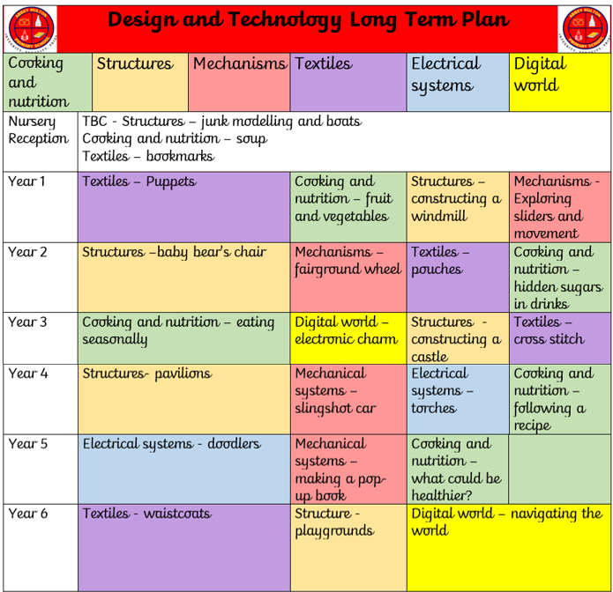

Teaching and Learning Style

Design and Technology will engage the children in a broad range of designing and making activities which involve a variety of methods of communication, eg speaking, designing, drawing, assembling, making, writing and using information and communication technology from Early Years up to Year 6. These activities can be differentiated through careful planning and the selection of resources which are appropriate for different ages and abilities. All children must be encouraged to design and make and must be stretched in designing and making. Writing frames can be modified easily to support or stretch children. Projects are taught in alternated blocks with Art and Design to ensure full curriculum coverage, this allows for more effective learning in which teachers can focus on DT skills. Teachers will ensure that they have a clear idea of the skills, knowledge and understanding to be taught in each unit of work that are indicated in the long term planning which takes into consideration all aspects of the DT curriculum. Units of work have been selected and planned to ensure a balance of materials, skills, knowledge and understanding throughout each Key Stage. Each unit has been designed to take into consideration the design process through making and construction and also cooking. All children should have a breadth and balance of experience. Care should be taken to ensure activities do not have a gender bias. Use of multicultural stimuli wherever possible enhances and enriches design possibilities.

Inclusion

Teachers ensure that children have access to the range of Design & Technology activities and use opportunities within Design & Technology to challenge stereotypes. Children are encouraged and supported to develop their Design & Technology capability using a range of materials. Teachers differentiate activities within Design & Technology to ensure that the specific needs and interests of individual children are best met.

Assessment

Assessment in DT is carried out via foundation subject assessment grids. Using the ‘what do you know’ statements, teachers use their formative and summative assessment to form a baseline judgement of whether the child is working towards, at, or above expected national standards for their age.

Resources

Resources audits are taken annually to track resources. Children have been taught to respect resources in class particularly when using glue guns, cooking utensils etc. All resources have been categorised by key stage and age to ensure appropriate resources are being used for every year group. Online resources can be accessed to enhance and support teaching.

Equality

Under the Equality Act 2010 we have a duty not to discriminate against people on the basis of their age, disability, gender, gender identity, pregnancy or maternity, race, religion or belief and sexual orientation. This policy has been equality impact assessed and we believe that it is in line with the Equality Act 2010 as it is fair, it does not prioritise or disadvantage any pupil and it helps to promote equality at this school.

Monitoring and review

The monitoring of Design and Technology is the responsibility of the topic curriculum leader, in line with the school’s monitoring cycle. Documentation of monitoring is collated by the curriculum leader and given to the Head Teacher. Annually the curriculum leader presents a review to curriculum governors evaluating the subject area and indicating areas for future improvement. Action plans are updated termly, scrapbook monitoring is completed termly as are learning walks, peer reviews, drop ins and staff meeting updates. All paper work is kept in the Design and Technology subject leader file.

This policy will be reviewed: July 2025

